George C. Brown  Mayor | Building Code  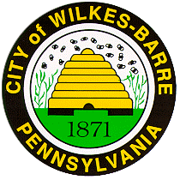  Enforcement | 1st Floor, City Hall  40 East Market St.  Wilkes-Barre, PA 18711  Phone: 570.208.1629  Fax: 570.208.4187

Pave Cut Permit Application
All submitted Pave Cut Permit Applications will be available for pick up after 12:00 PM on the 3rd Business Day

For official use only: Amount: __________
Permit #: ___________________________ Cash: _____________
Type: BT:_____ SW:_____ TL: _____ Check #: __________

Permit Fee |  | $100.00
Plus | Price per Sq. Ft. | +
Blacktop (BT) | ____sq. ft. x $7.27=
Sidewalk (SW) | ____sq. ft. x $3.65=
Tree Lawn (TL) | ____sq. ft. x $2.92=
 | TOTAL: | $

Start Date: __________________________ End Date: ___________________________
Owner: ____________________________________ Phone #: ____________________________
Address: _____________________________________ City/State/Zip: _______________________
Cut Location: _________________________________________________________________________
Cut Size: _________________________ Contractor: ________________________________________
Work Description:
____________________________________________________________________________________
____________________________________________________________________________________
____________________________________________________________________________________
____________________________________________________________________________________

Owner/Contractor Signature: ____________________________________ Date: ____________

For inquiries, contact Joe Rodano, Pave Cut Coordinator at 570.208.4167 or jrodano@wilkes-barre.pa.us.

